NauticEd and MarineVerse Launch
World’s First Virtual Reality Sailing Course
The virtual reality sailing training is expected to revolutionize sailing education
by better preparing and entertaining sailors

AUSTIN, Texas – Oct. 5, 2022 – NauticEd, the world leader in on-the-water and online sailing training, today announced a partnership with MarineVerse, an Australian-based pioneer of virtual reality (VR) sailing simulation, to jointly offer the first-ever virtual reality sailing course incorporating VR gaming with sailing training techniques and programs.

The initial VR sailing course, “Self Mastery,” was co-developed by the two companies and features sailing training that balances authenticity and entertainment in a fully immersive, virtual sailing experience.
The training puts players at the helm of a sailing yacht and helps them learn to trim the sails, manage boat speed, and navigate. The boat reacts to wind conditions and every decision made by the players, giving them instant feedback on how their actions impact boat behavior. Other more complex modules like docking and maneuvering within the marina, night sailing, and heavy weather are also in production for future accessibility.
“How do you make sailing less intimidating and open to more diverse types of sailors? How do sailors keep learning and continue to practice what they have already learned when they can’t access the water? The answer is VR, and we believe it will be revolutionary for sailing education,” said Grant Headifen, founder and global director of education for NauticEd. “As experienced sailors have known for thousands of years, competence requires theory knowledge, practical skills, and lots of experience. VR combines all aspects into a fluid, immersive and fun experience that pushes the boundaries of a user’s imagination in a safe and non-intimidating training environment.”

The metaverse has grown exponentially in the past two years -- mostly through games and fitness apps. With devices like Meta Quest 2 becoming increasingly popular and affordable, NauticEd recognized the opportunity to leverage the unique capabilities of VR and MarineVerse’s innovations to enhance and transform sailing instruction. MarineVerse wanted to leverage the growth of modern sailing education as part of its vision to make sailing more accessible and entertaining. Their partnership coincides with the fact that online sailing course enrollment has boomed since the pandemic began, with NauticEd reporting a 43% growth in registrations over the past 24 months.

Greg Dziemidowicz, founder of MarineVerse, is equally excited about the partnership.
“Sailing has always been about community for me,” said Dziemidowicz. “With NauticEd we will make sailing instruction more affordable and accessible while inspiring, educating and entertaining a fast-growing community of sailors.”

In addition to NauticEd’s sailing education and certification programs, the partnership also delivers the full experience of MarineVerse Cup VR. Gamers not interested in a certification course can simply give VR sailing a try as they learn, race, and explore the MarineVerse with no prior sailing experience required. All participants can enjoy the MarineVerse online community and race against people from all over the world.

NauticEd Instructor Trainer Edward O’Connor, a retired U.S. Marine Corps Lt. Colonel and Navy Top Gun Instructor Trainer, believes VR training for sailing is a true game changer.

“Just like a flight simulator, virtual reality activates the same neural pathways found in real life. By engaging the whole mind and body, VR builds muscle memory and enables longer retention,” he said. “The real benefit of a VR learning environment for new trainees is that the cost of mistakes is non-existent. This leads to a relaxed and less anxious and less nervous experience.”

O’Connor, who helped develop the NauticEd Instructor training program, predicts instructors will be “simply astounded” by new students’ abilities after they have completed the new VR sailing course. He submits VR will better prepare students for real world, on-water training where they can leverage their experience to advance faster.

The virtual reality sailing course featuring the “Self Mastery” module is now accessible via the NauticEd website at nauticed.org or via the MarineVerseCup app on Meta Quest. The MarineVerse Cup app requires a Meta Quest VR headset which is available for purchase at the Quest Store.

About NauticEd
NauticEd is a fully recognized education and certification platform for sailing students combining online and on-the-water real instruction (and now VR). Since Grant Headifen founded NauticEd in 2008, students have taken over a quarter million sailing courses from its e-learning platform combined with on-the-water experience via partner sailing schools and instructors in 23 countries. NauticEd offers 24 online courses, an electronic logbook, a sailing resume building tool, and six ranks of certification – all integrated into NauticEd’s proprietary platform. The U.S. Coast Guard and the National Association of State Boating Law Administrators (NASBLA) recognize NauticEd as having met the established American National Standards. For more information, please visit www.nauticed.org.

About MarineVerse
Started in Melbourne, Australia in January 2016 MarineVerse is an international team of creatives and advocates for sailing and emergent technology. With a mission to inspire, train and connect sailors around the world as well as share the unique feeling of sailing with a global audience, MarineVerse launched MarineVerse Cup in 2022 to bring virtual reality sailing to standalone headsets. For more information, please visit www.marineverse.com.
# # #
Social Media Post: @NauticEd and @MarineVerse create first-ever VR sailing training program. Try sailing in virtual reality! Learn, race and explore the sailing MarineVerse.
#sailing #sailinglife #sail #sailboat #yacht #yachting #yachtlife #boat #boatlife #boating #sea #ocean #vr #gaming #VirtualReality #metaquest2 #marineverse
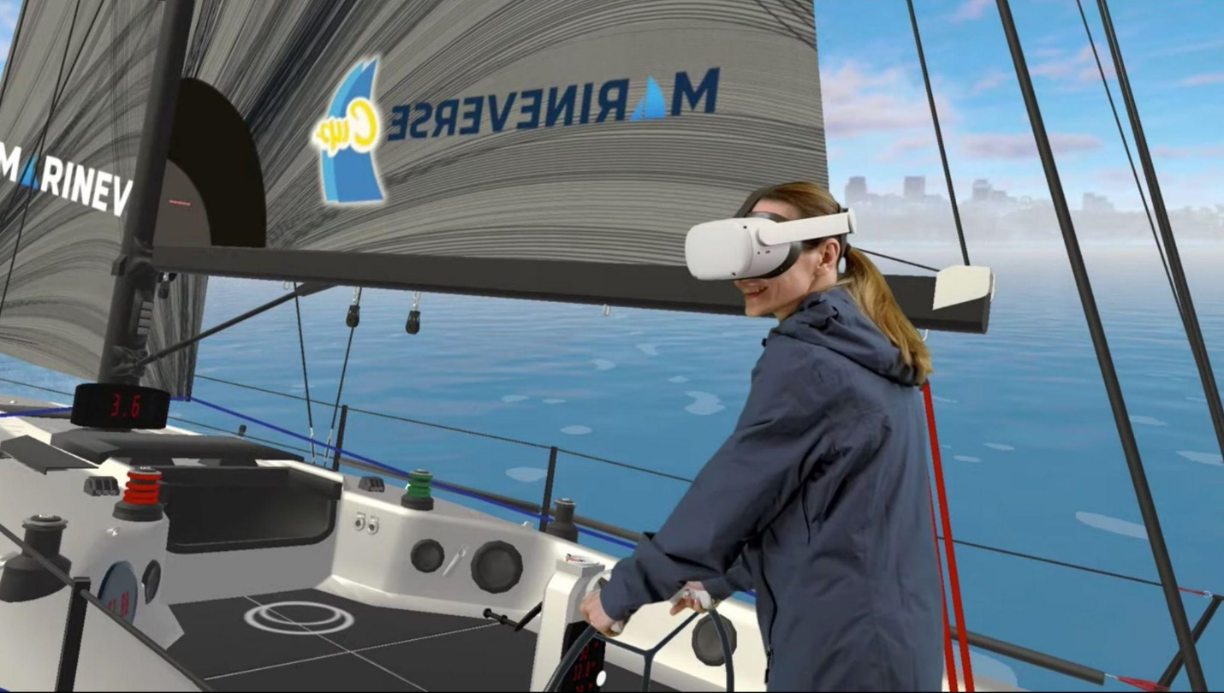
Photo Caption: NauticEd and MarineVerse launched the first-ever virtual reality sailing course incorporating VR gaming with sailing training techniques and programs. Participants are transported onto a virtual but highly realistic yacht where they learn how to trim the sails and handle different points of sail. The VR experience immediately enables them to see the impact of their decisions on the boat’s behavior.

Media Contacts:
Wanda Kenton Smith Joel Staley
wanda@kentonsmithmarketing.com joel@jcs-communications.com
(407) 697-8055 (407) 242-9994

